Purpose of the Interactive Notebook
To enable you to be a creative independent thinker and writer. Not "just another notebook." Like every notebook, it's a place to record notes in an organized, logical fashion. Unlike every other notebook, it allows you to repackage information in a way that will help you better understand history.

Format
When you open your spiral-bound notebook to the second page, you already see the left-side/right-side format.

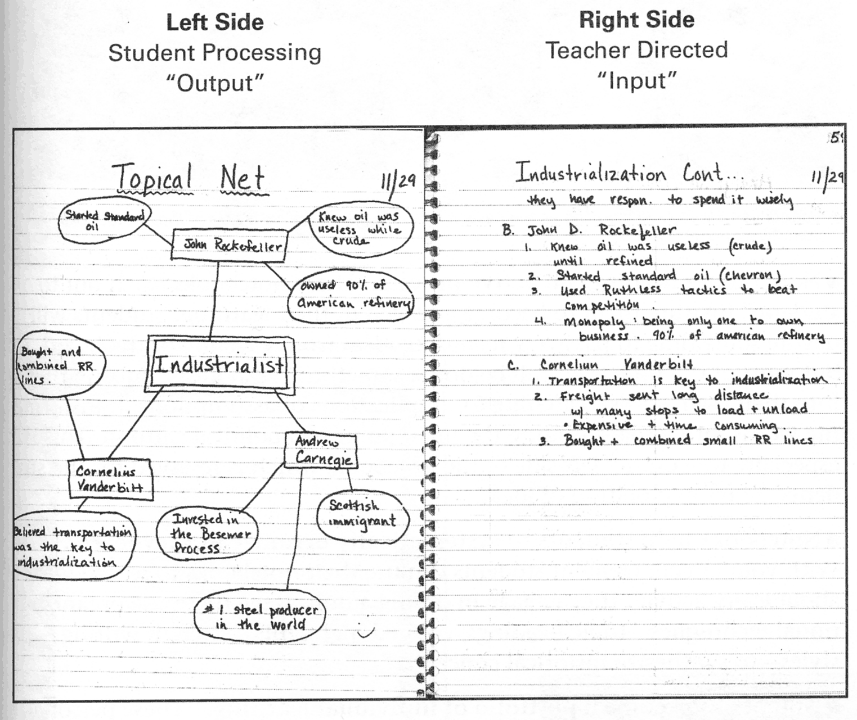
On the left side ("the output side") you process your new ideas. Here you create illustrations, diagrams, flow charts, poetry, cartoons, and more. You write your opinions, record "what-if" situations, and ask questions about new ideas. | On the right side ("the input side") you record class notes, discussion notes, and reading notes. This is the traditional part of note-taking.

Materials needed
- Spiral-bound notebook (3-hole punched; college-ruled; at least 70 pages)
- Colored pens or pencils
- Highlighters
- Gluestick
- 3-ring binder with four sections for the following
  - reading handouts
  - notes sheets
  - quizzes and tests
  - assignments and projects

You do not have to bring the 3-ring binder to class every day, but you do have to bring the spiral-bound and your writing utensils!

Grading
Your interactive notebook will be graded in two ways:
- 5 points for completion of regular assignments on the “left side. (These assignments are graded binarily, that is, you get the 5 points if you completed it on the day it was due or 0 points if you do not do it at all.)
- 45 points for over-all maintenance of your interactive notebook. Here’s the point-breakdown:
    - 15 points: quality – the effort and creativity you put into your notebook. This includes visual appeal and mastery of content.
    - 15 points: organization – the way you record your notes and ideas so that anyone can follow your train of thought and find information easily.
    - 15 points: thoroughness – this is not only the consistency with which you record your class notes in the spiral bound, but also how you keep the miscellaneous papers in your 3-ring binder, that is, all the handouts, notes sheets, quizzes, tests, and research papers that don’t fit in a spiral-bound notebook.

Tips for Keeping Your Notebook
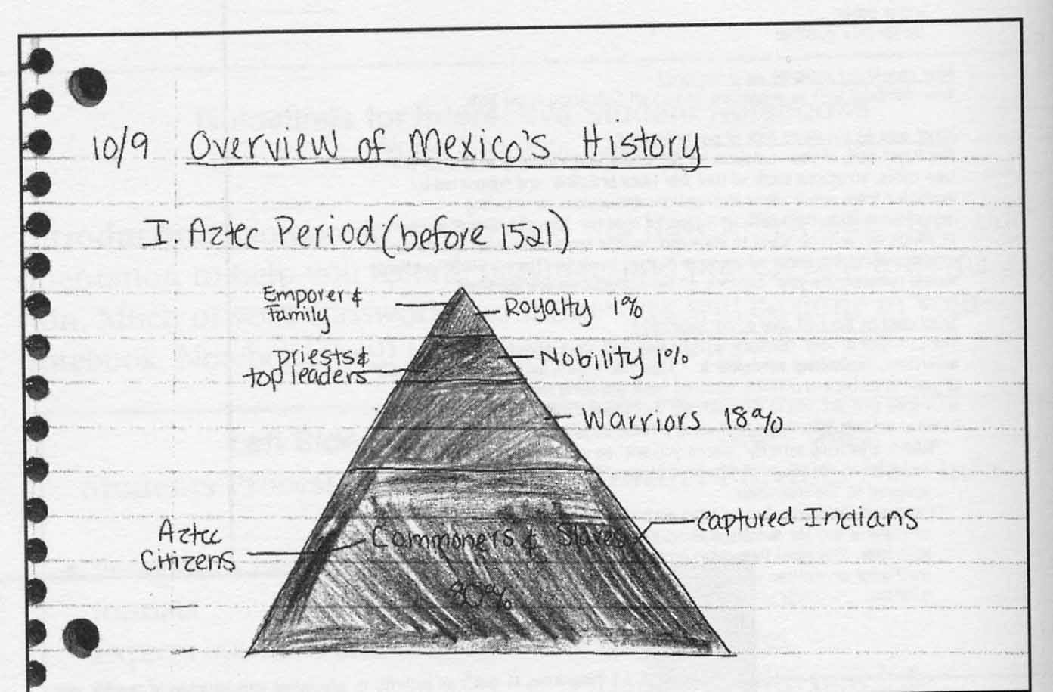 | On the right side of your notebook you will take notes, as presented in lecture. Be sure to maintain a consistent way of making entries in your notebook, for example, by recording the date and the subject of the lecture each time.

Create an interesting cover and unit headings that demonstrate your understanding of the topic. | 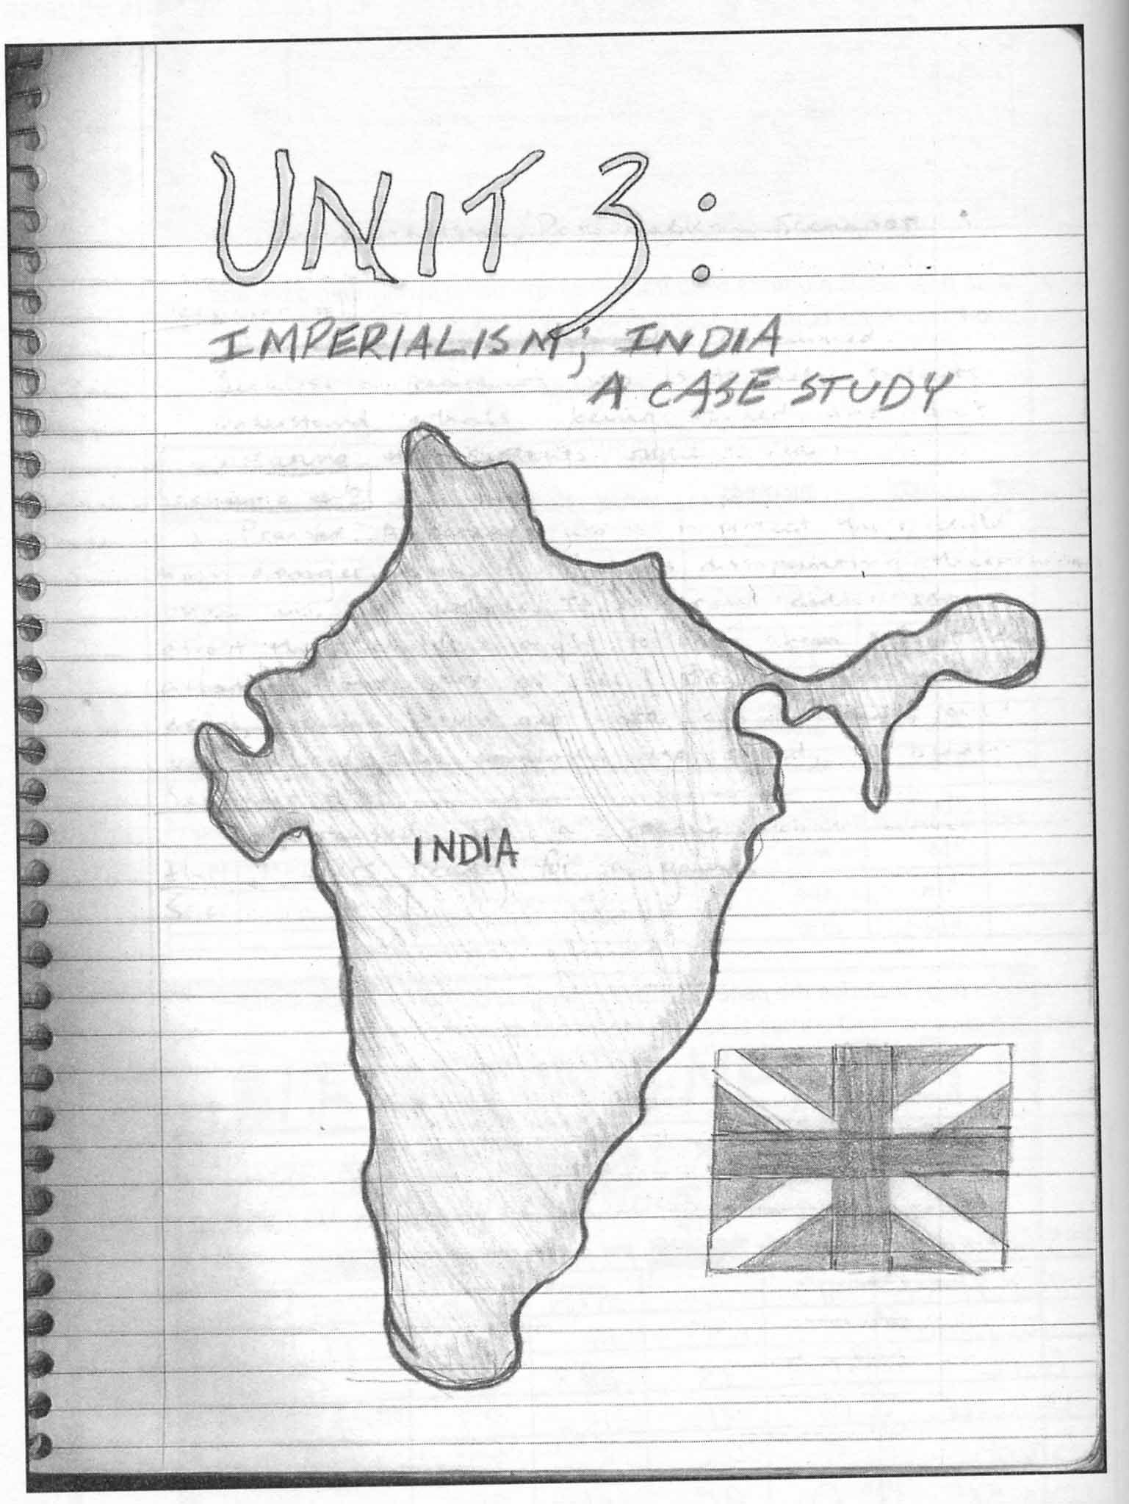

Throughout the course, there will be a variety of “left-side” assignments. The following examples of student work demonstrate just some of the different types.

Mosaic of themes in Mexican history. | 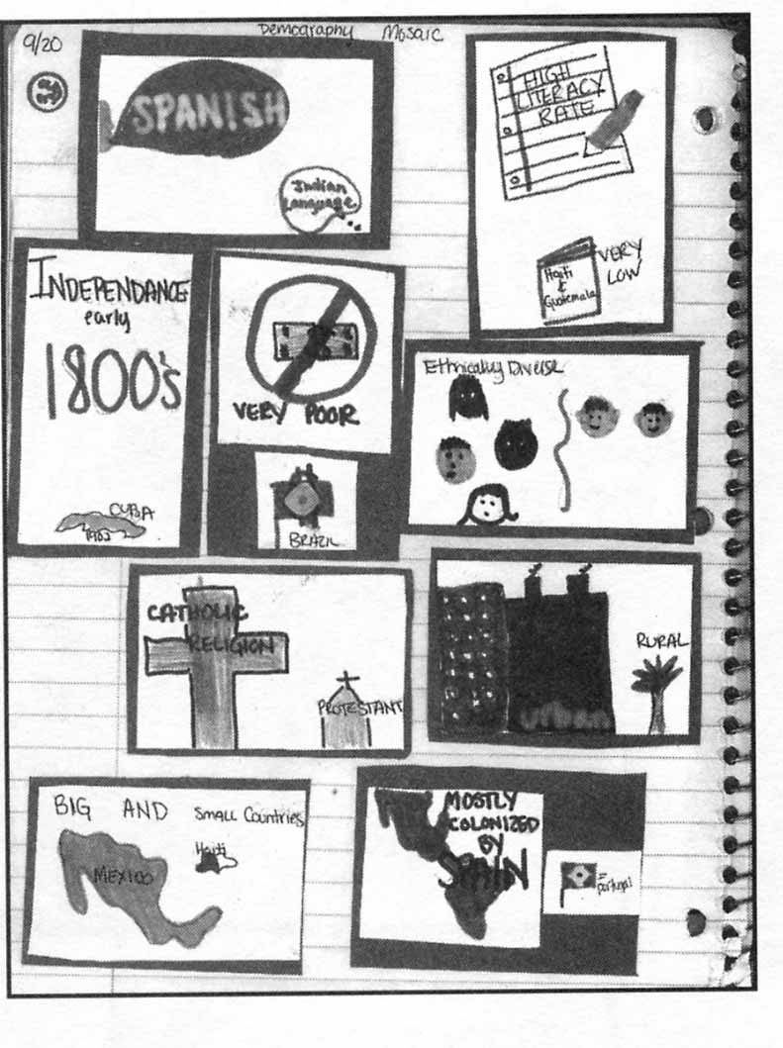
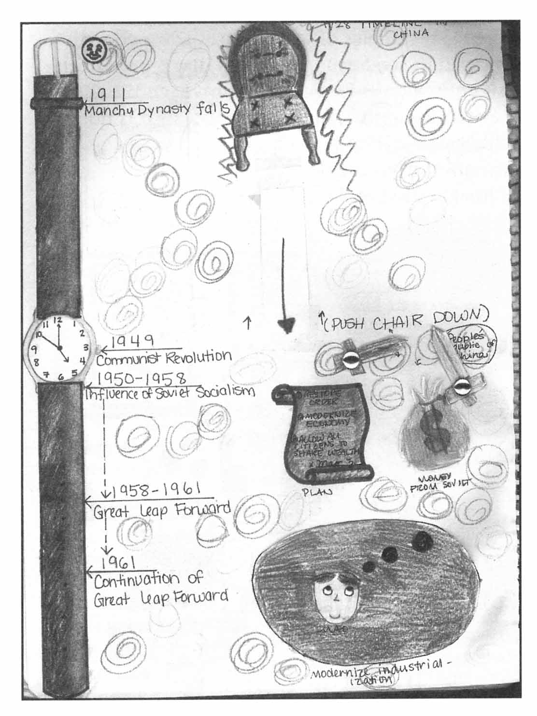 | Graphic timeline of milestones in China under Communist rule throughout the 20th century.
Character collage of Porfirio Diaz, Mexican leader of the early 20th century | 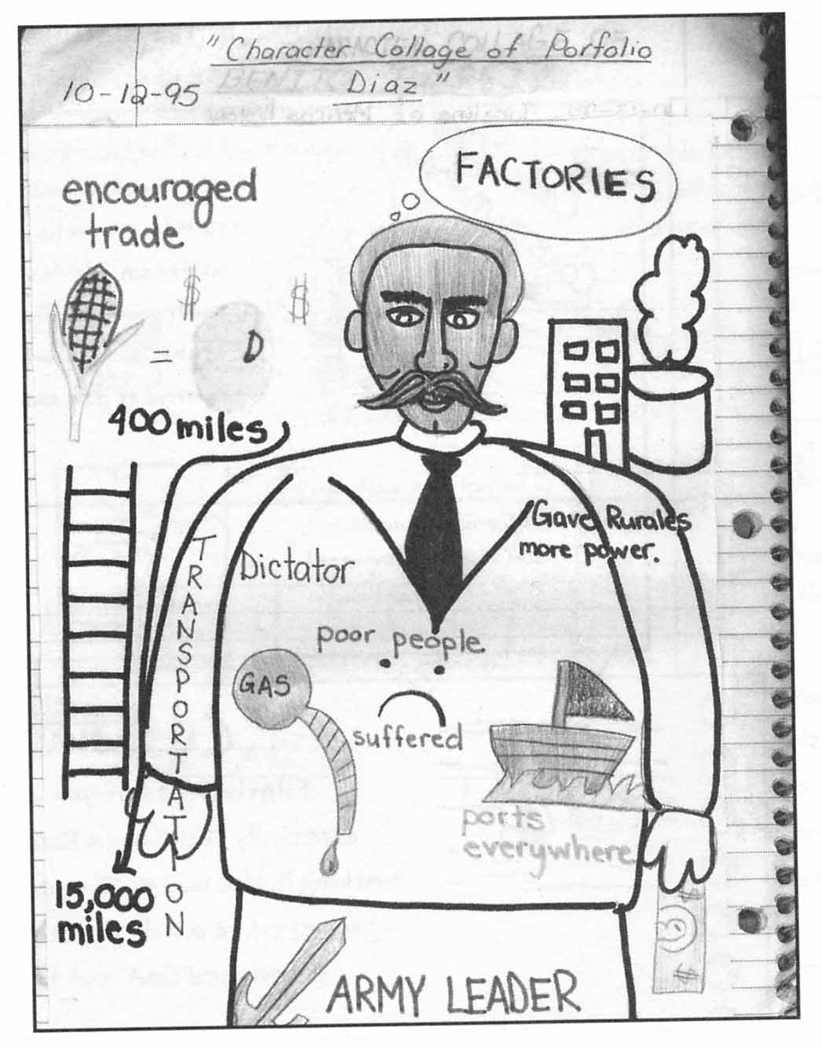

Above all, keep in mind: your interactive notebook is your opportunity to “own” information. The creativity and effort you put into it will determine the end result: making sense of this course of study.

